**Use JavaScript in adobe forms and display Footer only on Last page**

**Please use the previous Demo4_create tables and add the following to it**

1. Go to T code SFP. Copy Demo_4 Interface and Form created earlier.

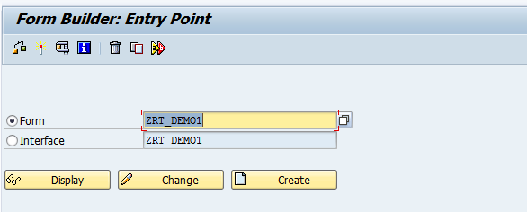

1. Click on Layout. In the Master Page, adjust the content area as shown below.

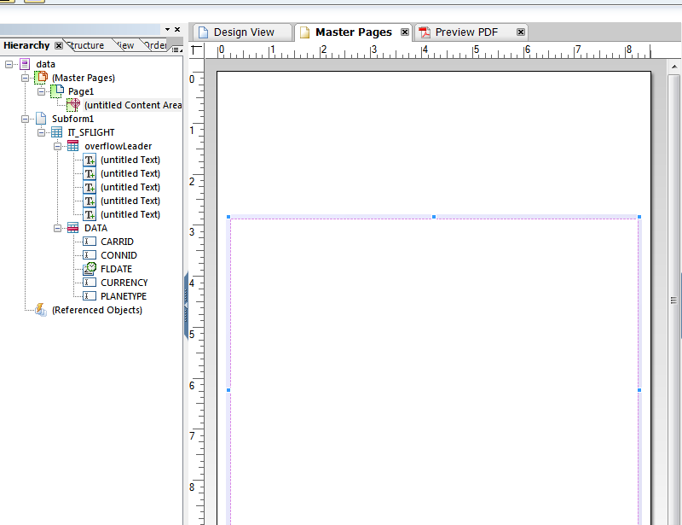

1. In the Master Page, drag and drop Image from 2 text fields from Object Library above the Content area. Name them as Signature and User.  
   Drag and Drop CurrentDate field.

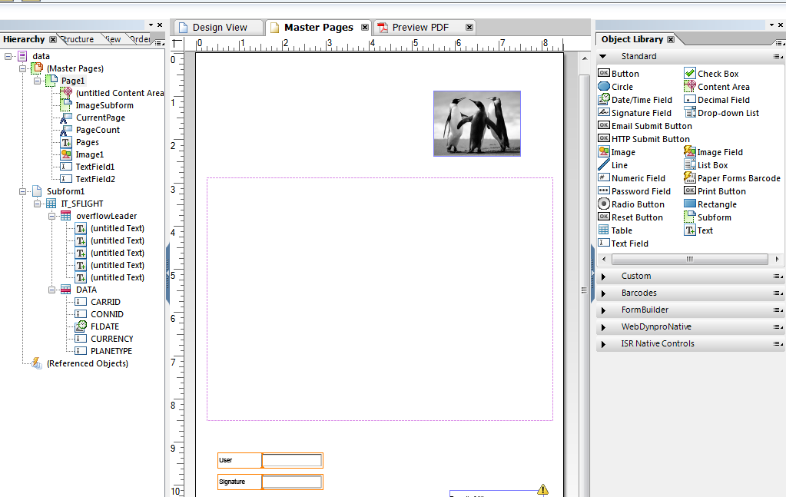

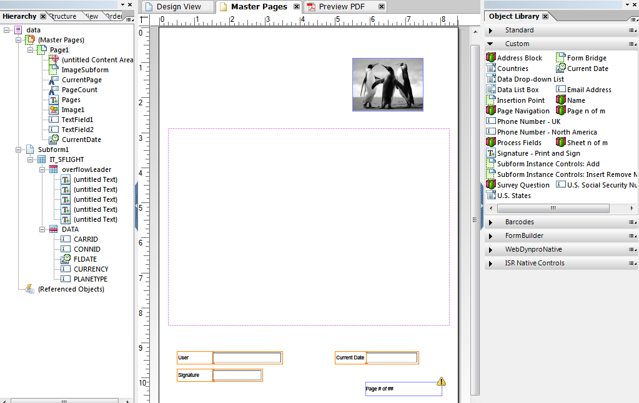

1. In the Hierarchy tab, right click on Image1 and select all three fields(Signature, User and Date) and wrap it into one sub form as shown below.

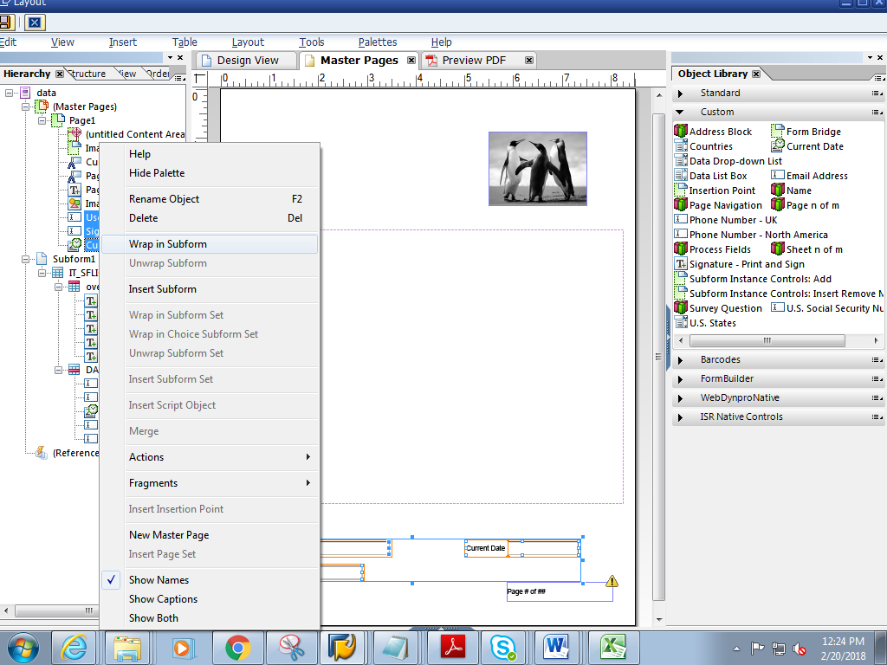

1. In the Hierarchy tab, rename the sub form to **FooterSubform** .In the Object window, choose **Positioned.**

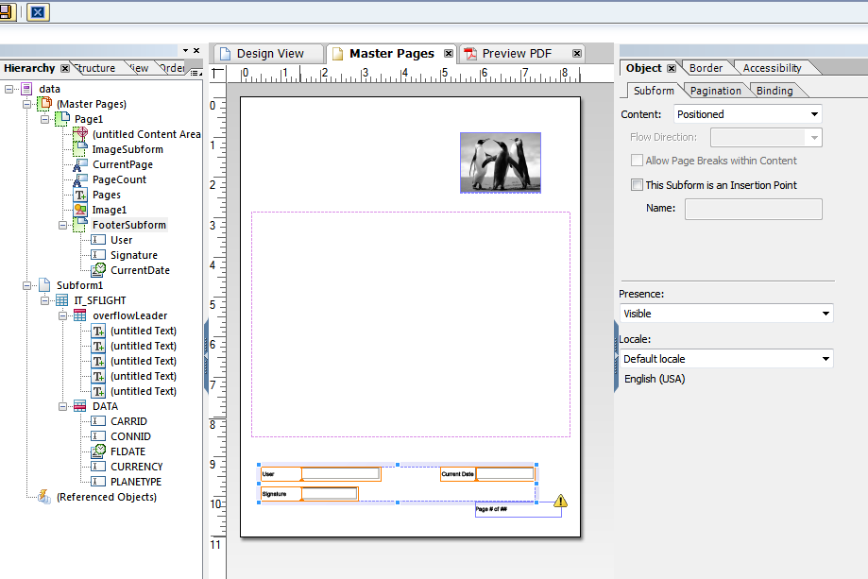

1. In the Border tab, select Edges **Edit Together** and select **Solid**  to give border to the subform

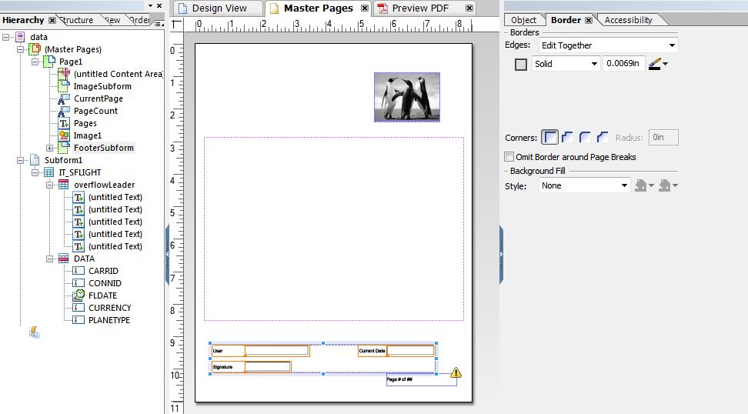

1. Double click on ImageSubform, go to Palettes->Script Editor

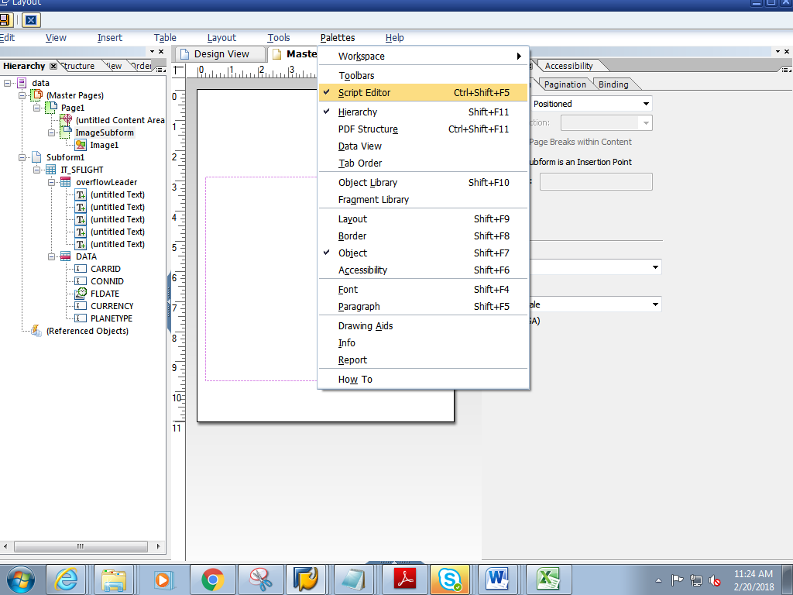

1. Add the below Logic in the script editor. (Note it should be **ImageSubform**::initialize section)

var curpage = $layout.page ( ref ( $ ) )

if ( curpage ne 1 ) then

$.presence = "hidden"

endif

1. In the script Editor, select Show : **Initialise**, Language :**FormCalc** and Run AT as **Client**

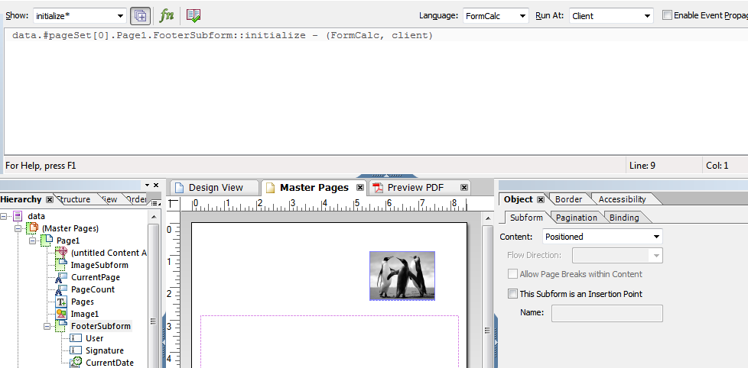

1. Add the below Logic in the script editor.(Note it should be **FooterSubform**::initialize section)

var curp = $layout.page ( ref ( $ ) )

var totalp = $layout.pageCount()

if ( curp ne totalp ) then

$.presence = "hidden"

endif

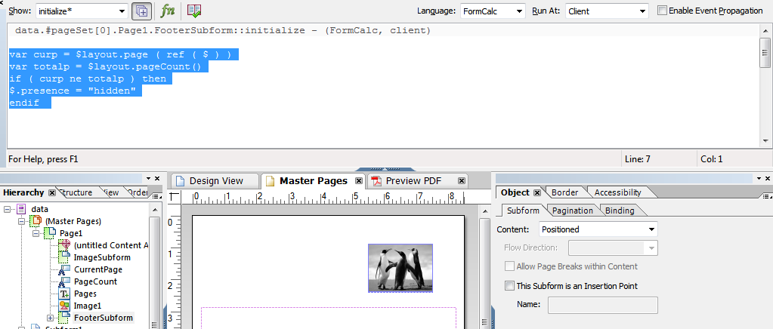

1. Save and close the Layout.
2. Click on context. Save and activate the form
3. Execute the form .Execute the function module

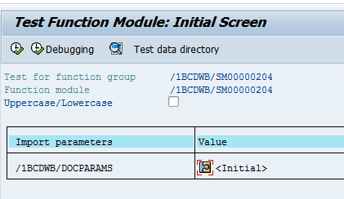

1. Click on Print preview

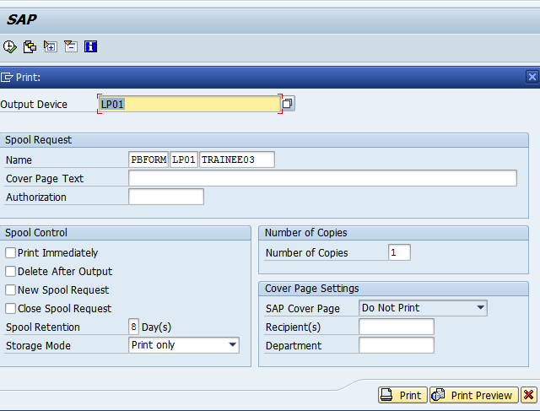

1. Expected output is as follows. Footer bock is displayed only on last page.

